**SARDAR VALLABHBHAI NATIONAL INSTITUTE OF TECHNOLOGY, SURAT**

**DEPARTMENT OF CIVIL ENGINEERING**

**STRUCTURAL ENGINEERING SECTION**

**ADVANCE CONCRETE TECHNOLOGY LABORATORY**

Advance Concrete Technology Laboratory was established in 2017. The laboratory is located in the ground floor of Advance Research Center (ARC-007). Postgraduate and Ph.D. research scholars utilize laboratory facilities for their curriculum laboratory work. Ph.D. Research scholars also utilize it for research purposes. Set-up like Corrosion Analyzer, Rapid Chloride penetration Test (RCPT), Sorptivity test, accelerated carbonation chamber and pH meter are available in the laboratory. It is one of the key laboratories for PG/Ph.D. students. The laboratory has good potential to carry out research and generate revenue using testing work. The list of equipment available in the laboratory is given below:

|  |  |
| --- | --- |
| **Sr. No.** | **Equipment Name** |
| 1 | Corrosion Analyzer |
| 2 | Rapid chloride Penetration test (RCPT) |
| 3 | Sorptivity test set up |
| 4 | Accelerated Carbonation chamber |
| 5 | pH meter |
| 6 | Water Distillation plant |

**Information Regarding Few Important Set-ups in the Concrete Technology Laboratory**

**Corrosion Analyzer**

The corrosion analyzer with Guard ring arrangement is used to measure the corrosion rate of Reinforced concrete elements. This instrument was imported from ACM instruments UK. There are different techniques such as half-cell potential, Linear polarization resistance (LPR), AC impedance spectroscopy and harmonic analysis can be carried out by using this instrument. In electrochemistry, potentiostats/galvanostats are used both in fundamental and applied research to gain an increased understanding of electrode processes, analytical chemistry, battery research, and corrosion research.

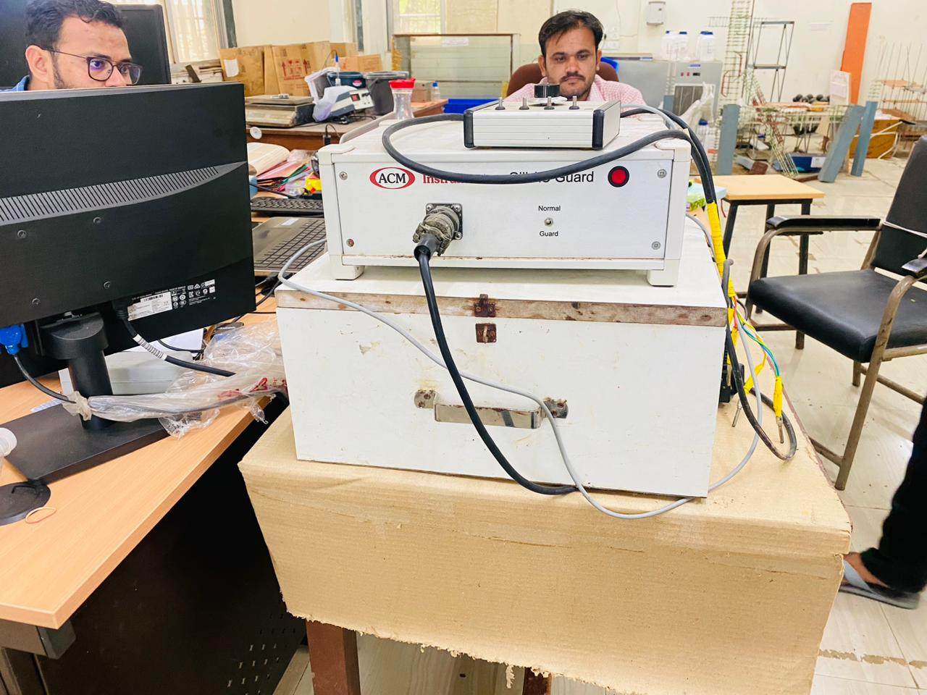

**Corrosion Analyzer**

**pH meter**

**pH meter** is an electric device used to measure hydrogen-ion activity (acidity or alkalinity) in a solution. pH meter consists of a voltmeter attached to a pH-responsive electrode and a reference (unvarying) electrode. The glass electrode develops an electric potential (charge) that is directly related to the hydrogen-ion activity in the solution (59.2 millivolts per pH unit at 25 °C [77 °F]), and the voltmeter measures the potential difference between the glass and reference electrodes.

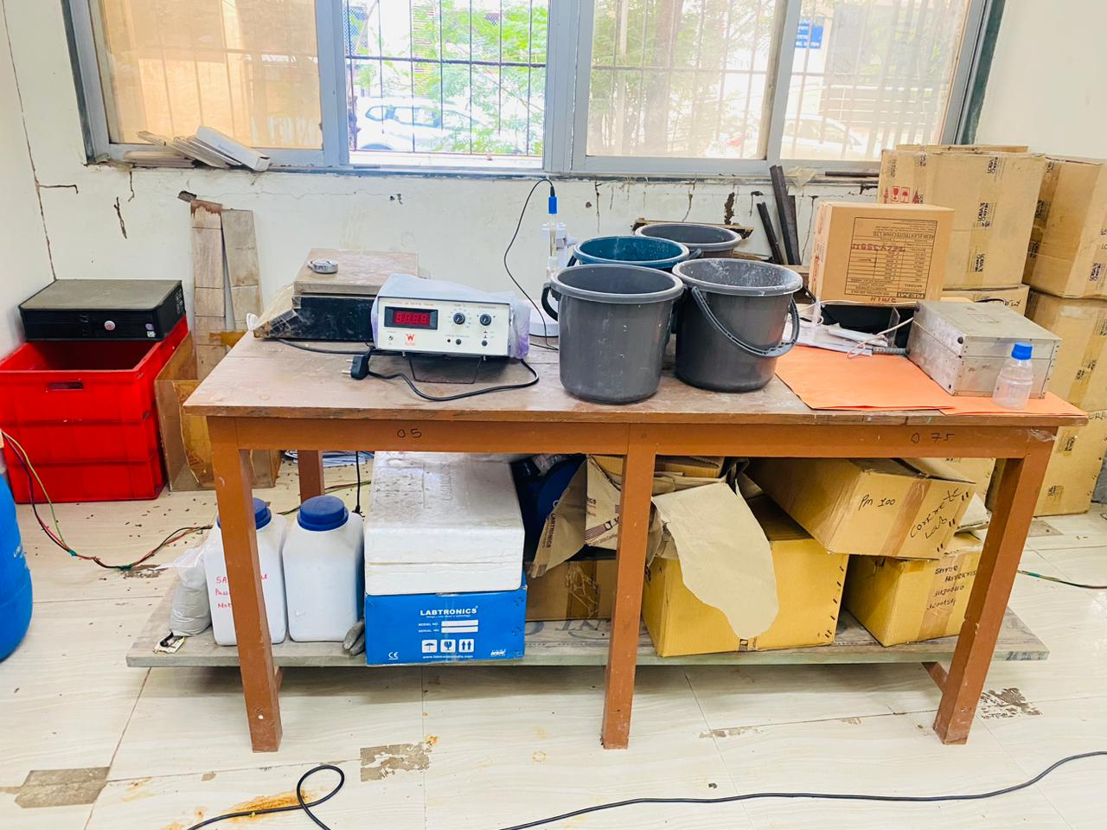

PH meter

**Accelerated Carbonation Chamber**

Accelerated carbonation chamber is used for the determination of in a concrete specimen’s carbonation depth with the required temperature and humidity conditions, at a certain concentration (20% or less) of carbon dioxide gas

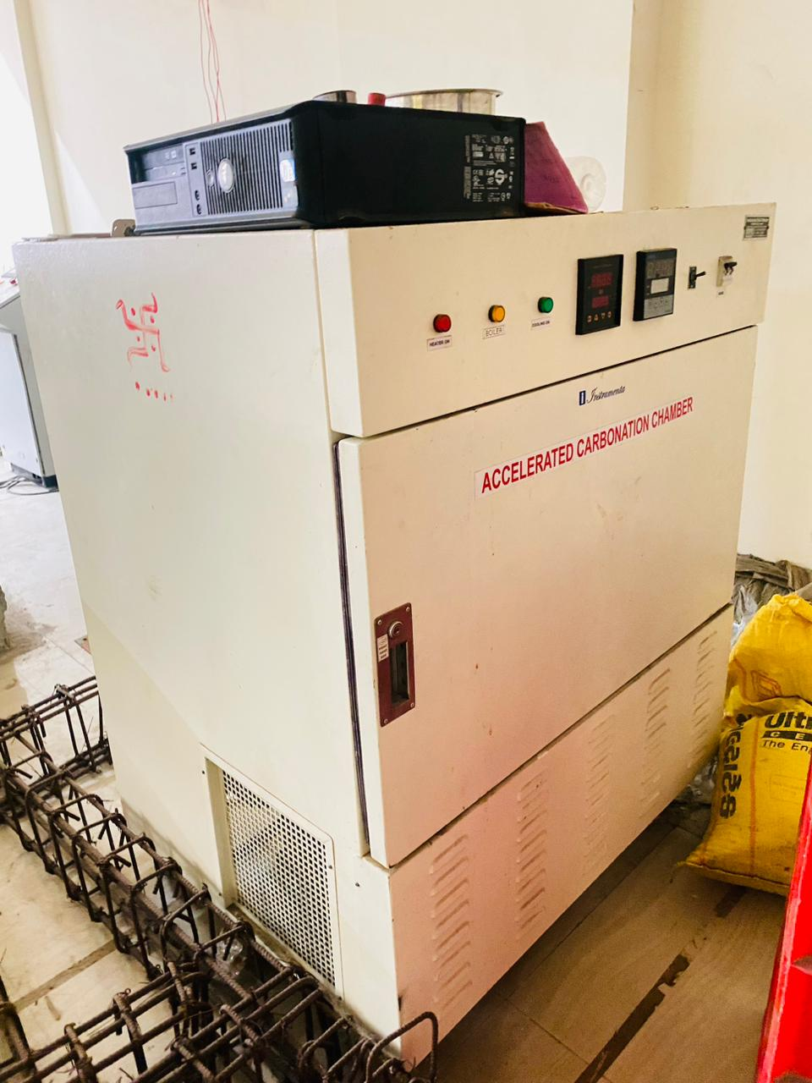

Accelerated Carbonation Chamber

**Rapid chloride penetrability Test**

The rapid chloride permeability test RCPT-ASTM C 1202 is **commonly used to evaluate the resistance of concrete to chloride ions ingress owing to its simplicity and rapidity**. RCPT is an electrical indication of concrete's ability to resist chloride ion penetration.



**Rapid Chloride Penetration Test (RCPT)**

**Water distillation Plant**

Water distiller is a machine which is used **to purify water using distillation process**, which is related to first boiling impure water after that collecting condensed water in a separate container.

This distilled water is used in laboratory, organic chemistry lab, clinic, fermentation and medical industry etc. The distilled water is used for preparing the concrete pore water solution and other chemical solutions.

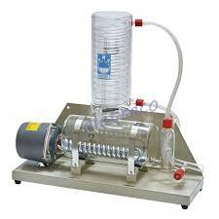

**Water distillation Plant**